Functional dependencies are there because they need to be enforced.

Validating functional dependencies, I am going to load the data.

I am going to talk about how I am going to enforce functional dependencies.

Functional dependency is only violated if there are two entries of the left hand side

Meaning that the same left hand side has two duplicate assignments to floor 10 room D which happens to correspond to a different company.

Because Floor and room can’t repeat, they make up the primary key so you can’r physically make two different assignments to the same floor on the same room and therefore functional dependency can never be violated.

And we need to check that this is true and the primary key is here to give us the same quick solution.

This is a redundancy, which incidentally normal forms strive to eliminate

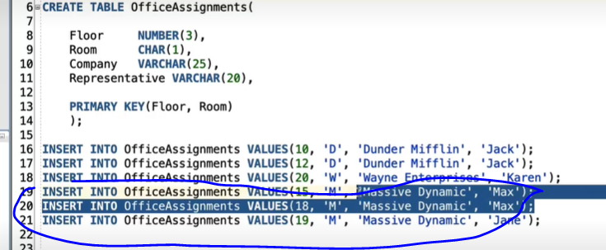

There are duplicate listings, we know that the name determines the name of the company and same here (representative -> Company).

We are going to write a SQL query that is going to express a functional dependency rule and look for violations.So, a violation is a situation where the same name corresponds to more than one company specifically for the last functional dependency, representative determines company so we are going to write a query using aggregation which is going to look for representative count,

Here Jack is assigned in two different places, but they’re not violating functional dependency because it’s the same company. So, what we really want is to count the number of distinct values of the company name.

As we have set out to find violations of functional dependency, we are going to add a condition that represents a violation which is when you have multiple assignments for the same person or having count

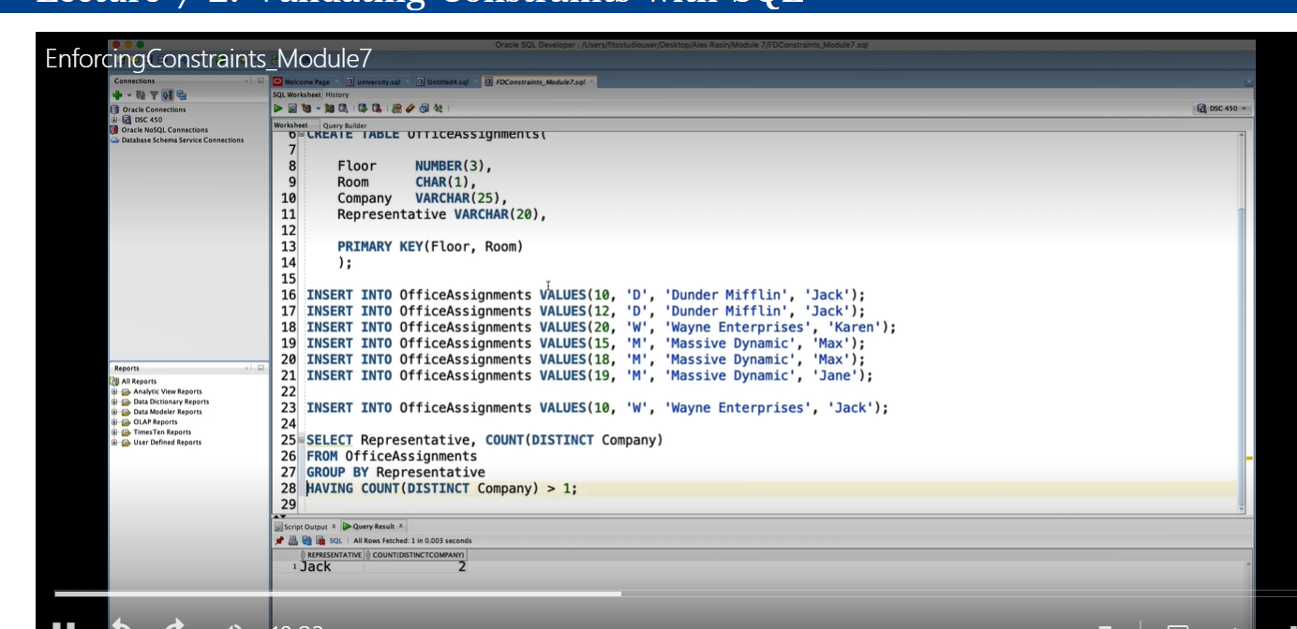

The above query identifies the violation indicating that representative Jack is assigned to different companies which violates the functional dependency of representative determines company

We fix this particular situation by normalizing the schema by normalizing it with respect to representative determines company, which will achieve the easy solution for checking this information as shown in the group by query above.

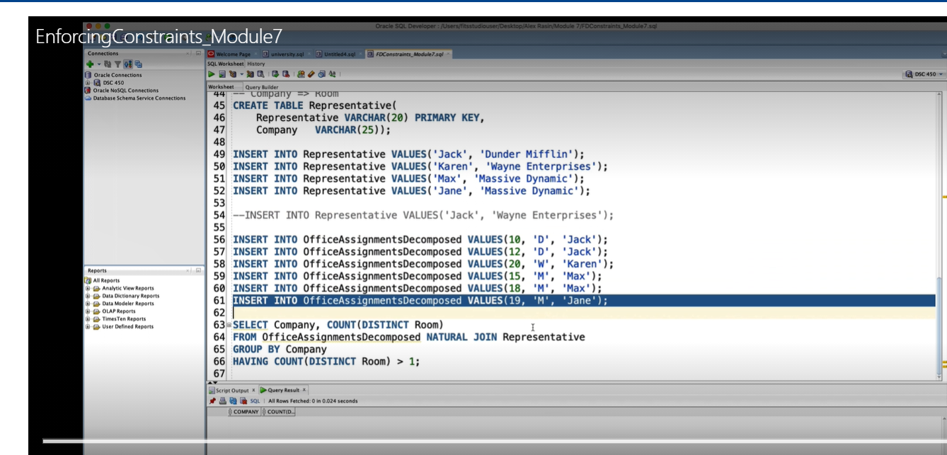

The company is placed into the new table and of course as part of the normalization, so we remove the company column from the original table so this is officeassignment decomposed and you still need a foreign key to link the two tables and this is going to be the representative column.

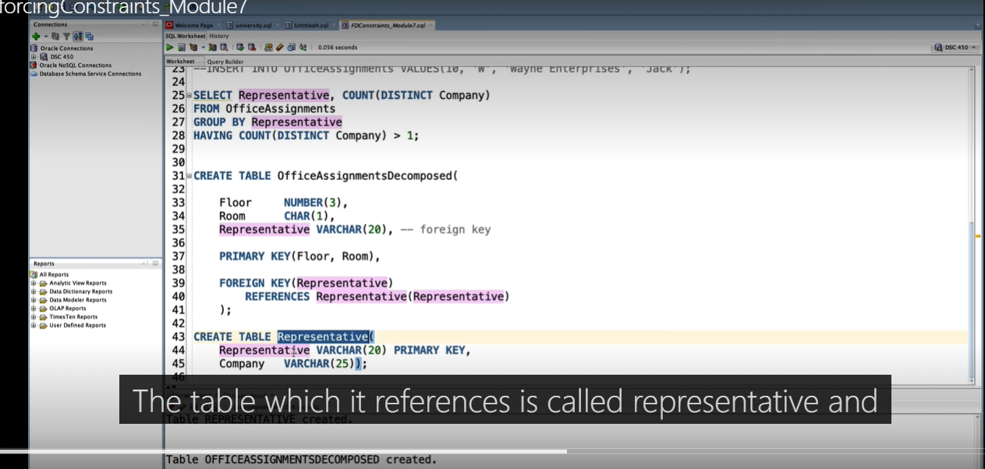

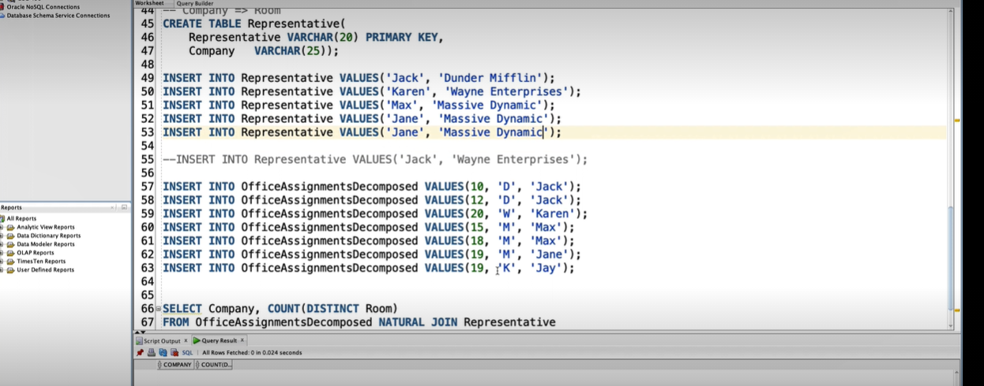

But let’s consider another example such as the representative determines company, which means a company can have multiple representatives like massive dynamics, but the same representative can not be assigned to a second company on top of the current one

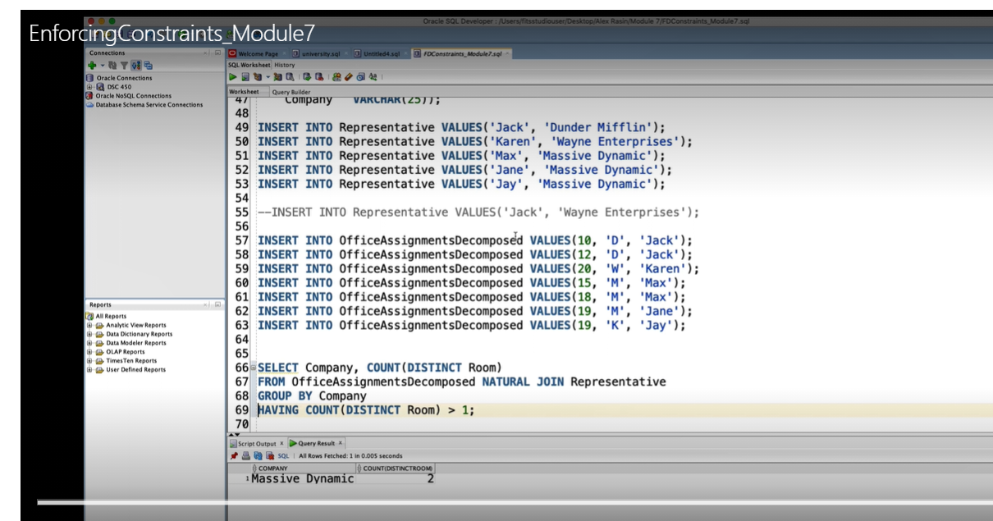

Massive dynamic doesn’t determine the room anymore because we have created a violation.

BCF normal form.

When you look at our functional dependency representative determines Company and Company determines room. So by transitiviy, as you know, representative determines room.

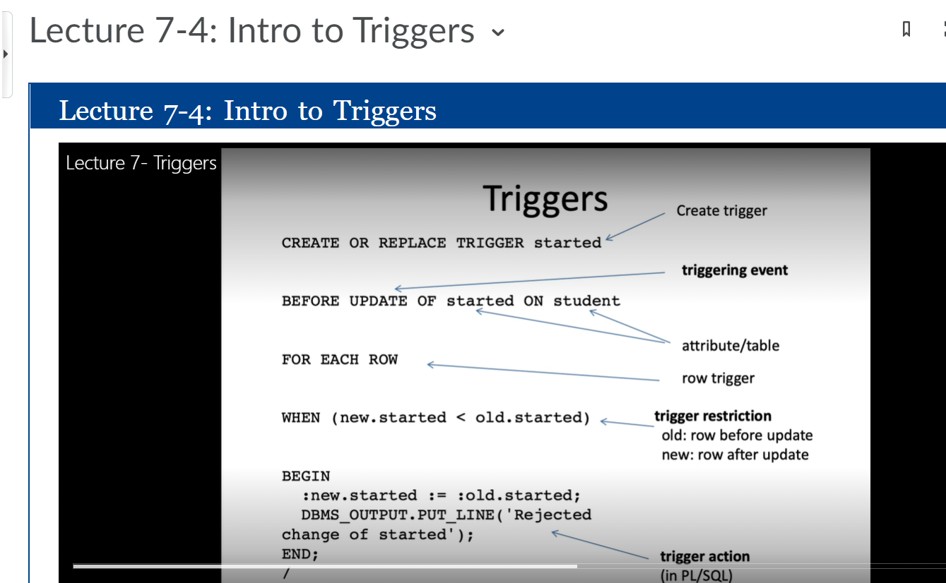

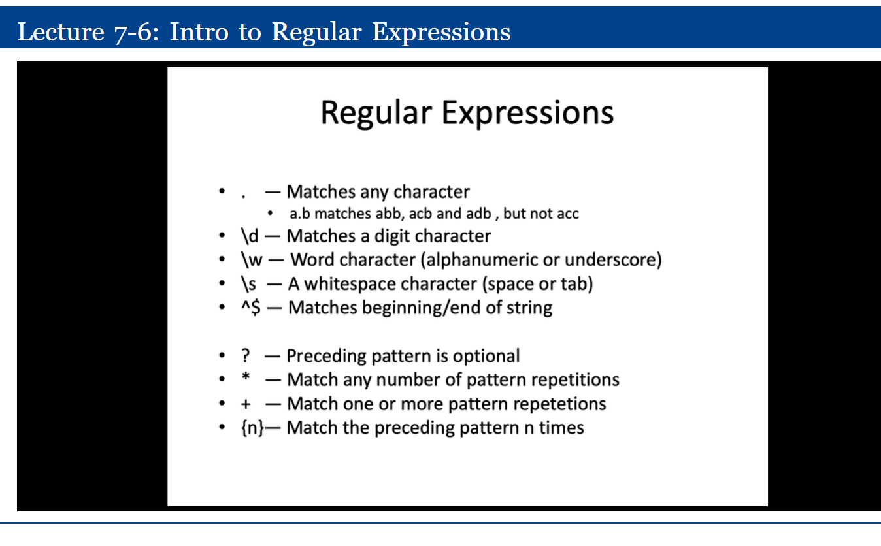

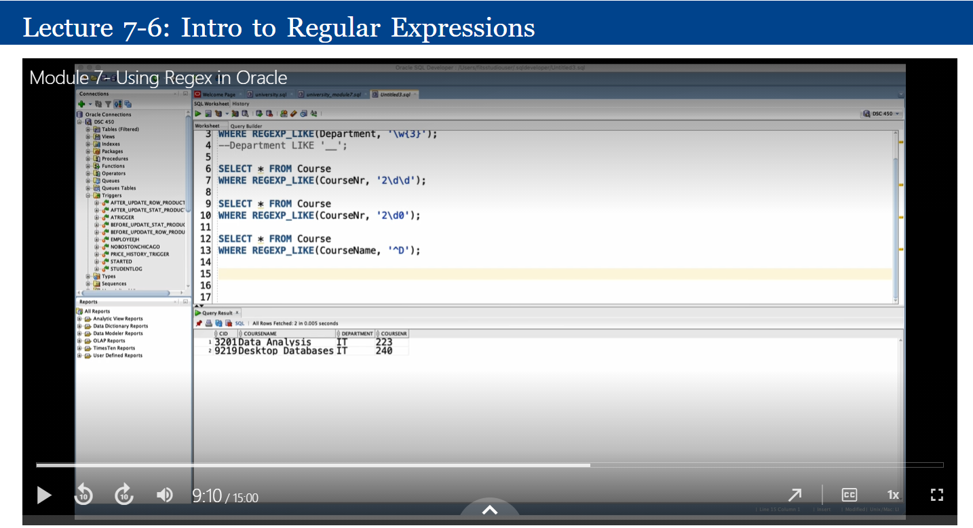

I am ensuring that it begins with character string which means you can’t have your name followed by a phone number. The very first thing has to be the phone pattern then I have the open parenthesis for the area code, and the reason there is an escape character here is because open parenthesis has other meanings. So, similarly, to how slash d refers to a digit, because d itself is just the letter d. Open parenthesis actually matches sub-patterns within the regular expression So what this indicates is that we explicitly mean open parenthesis and not any other special meanings.

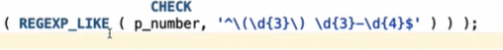

Open parenthesis, three digits, close parenthesis, space three digits, dash, four digits and the pattern.

Matching regular expressions to a string of characters.

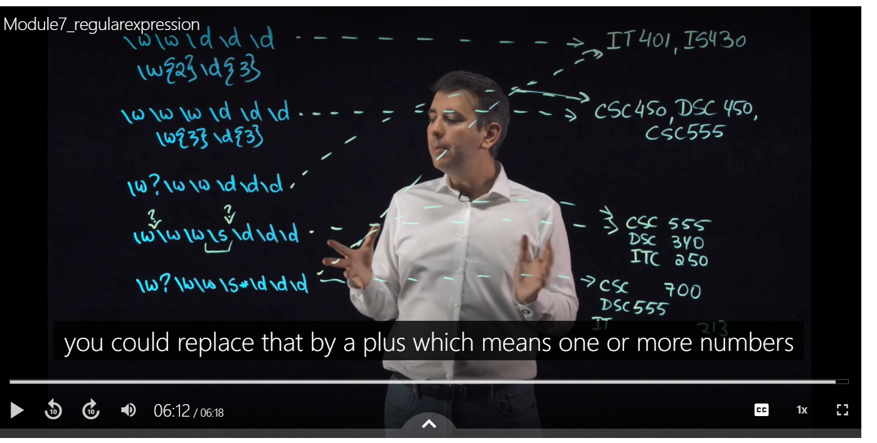

The plus indicates any number of things but at least one.

So asterisk says zero or more,

Question marks stands for zero or one, and plus stands for one or more for any number of the preceding patterns.

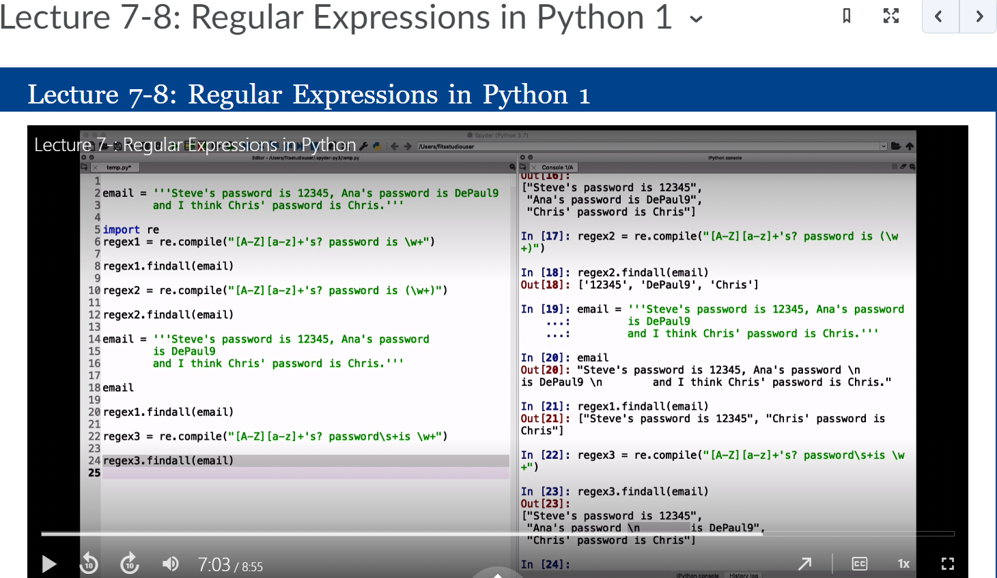

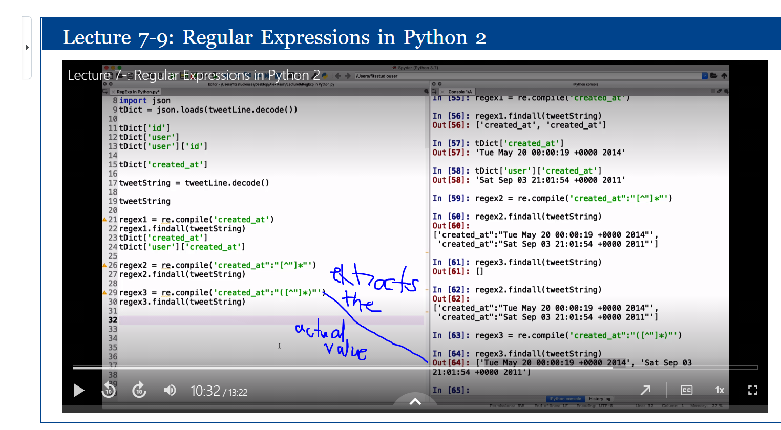

Open quotes then some number of letters and numbers which describes the field in double quotes, and then the rest remains the same and remove the parenthesis so that we match the whole thing.

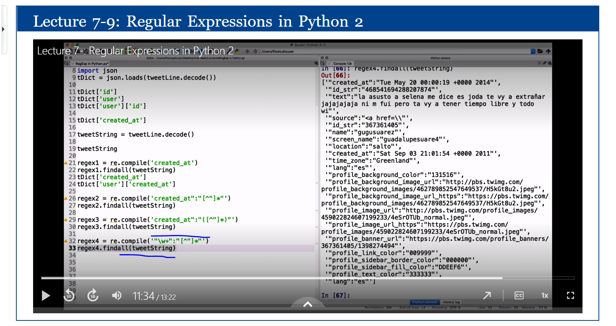

Executing this gives you all the fields surrounded by double quotes including created_at, source e.t.c

If I wanted to caputure field will null values or no values available do:

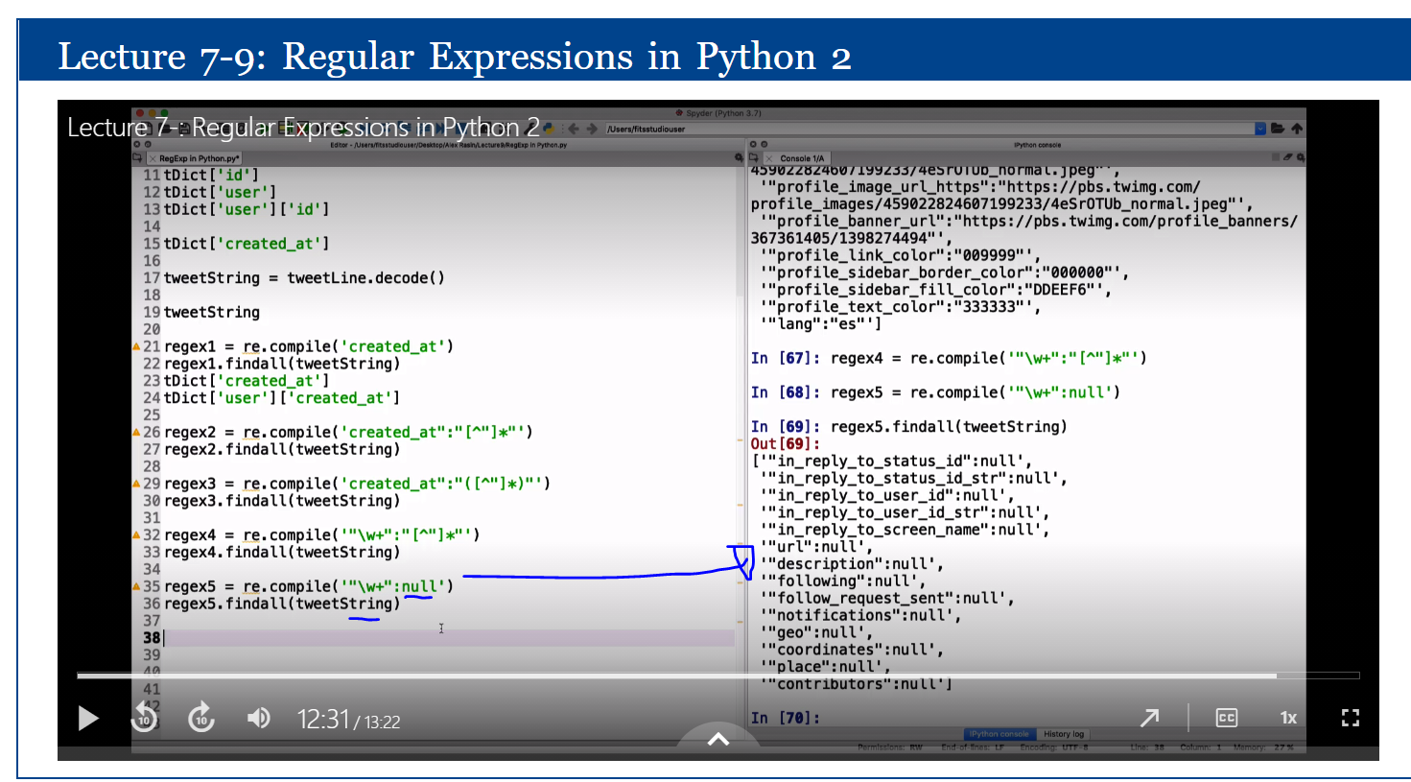

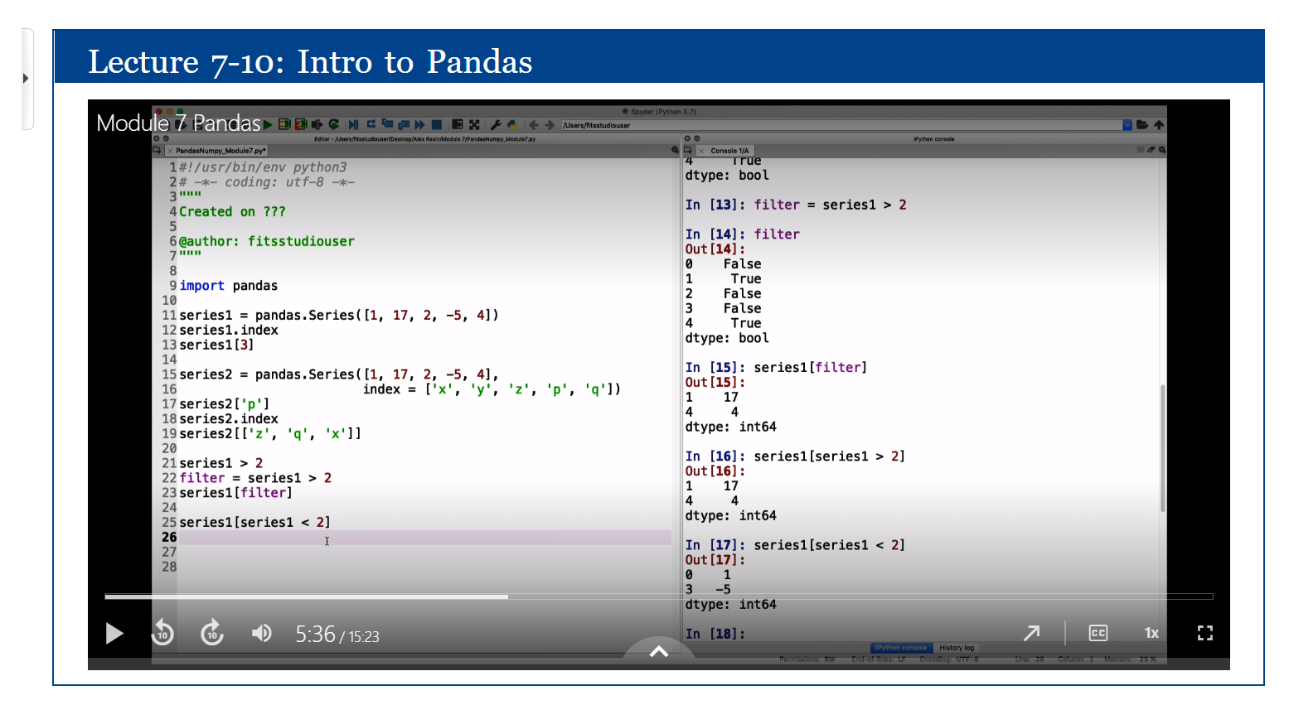

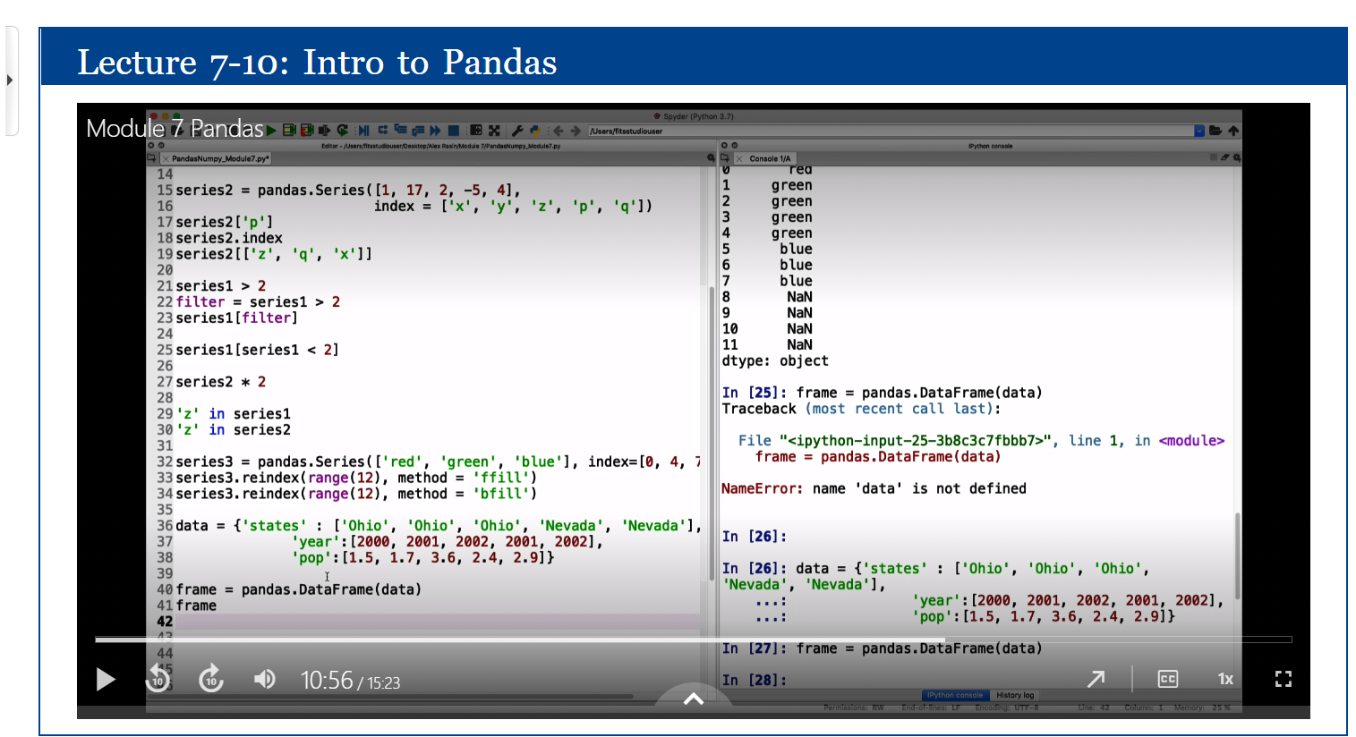

You can reorder the columns as indicated below:

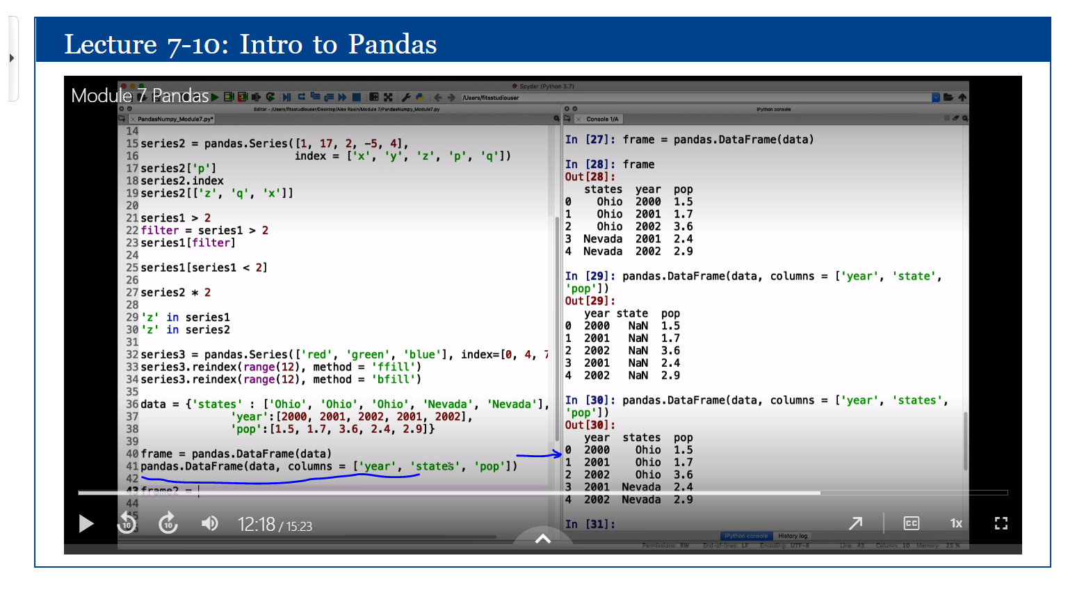

You could similarly reindex the rows instead of 0, 1, 2,3 as below:

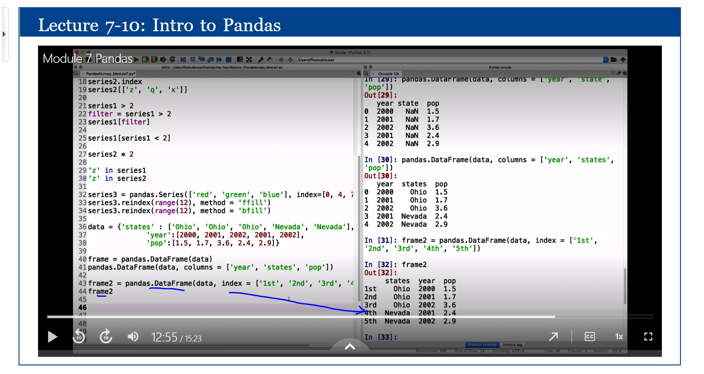

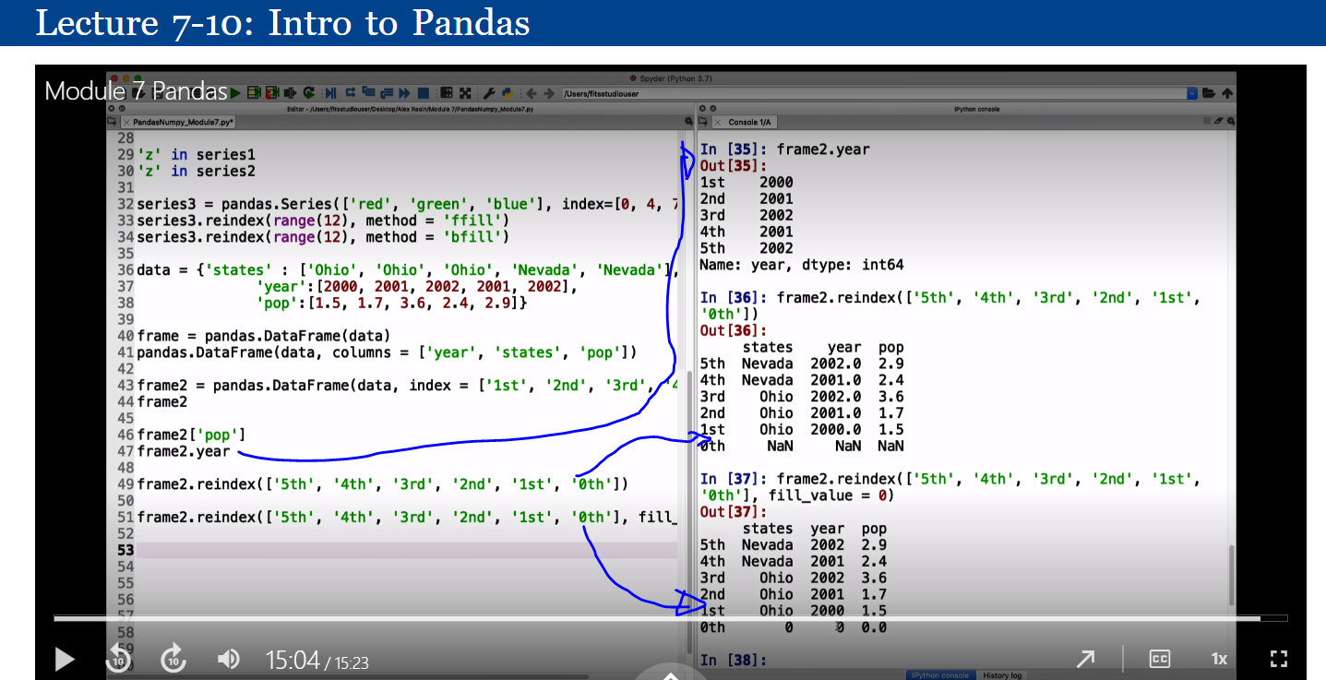

Introduction to Numpy.

This generates a 3 by 3 random numbers.

You can check the dimensions using the ndim property as below:

You can also specify the identity

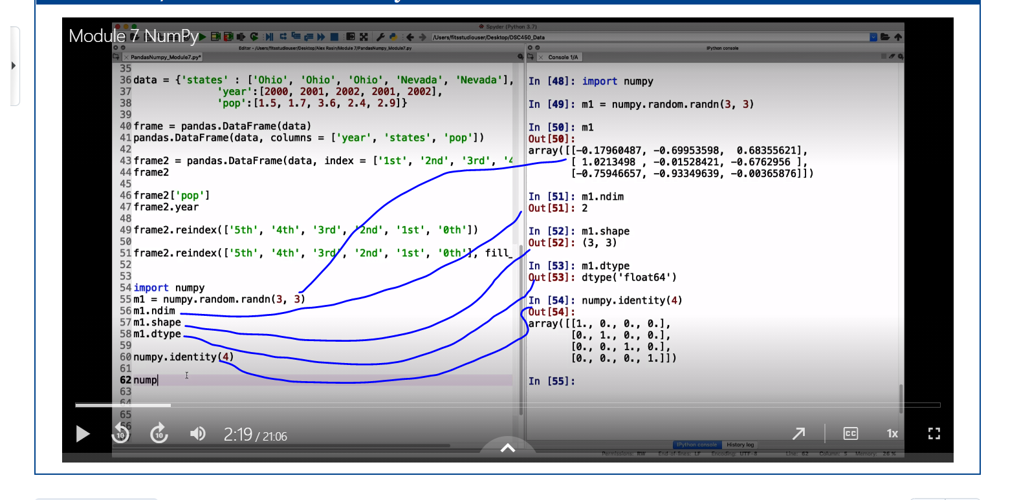

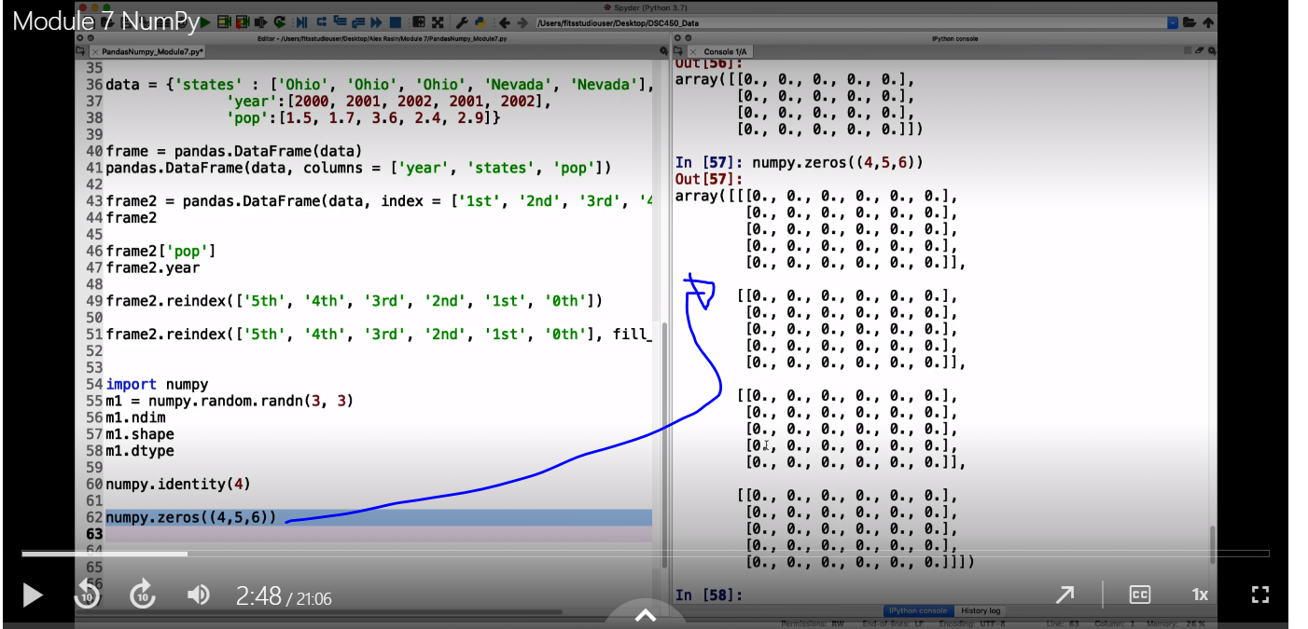

You can directly work with those arrays.

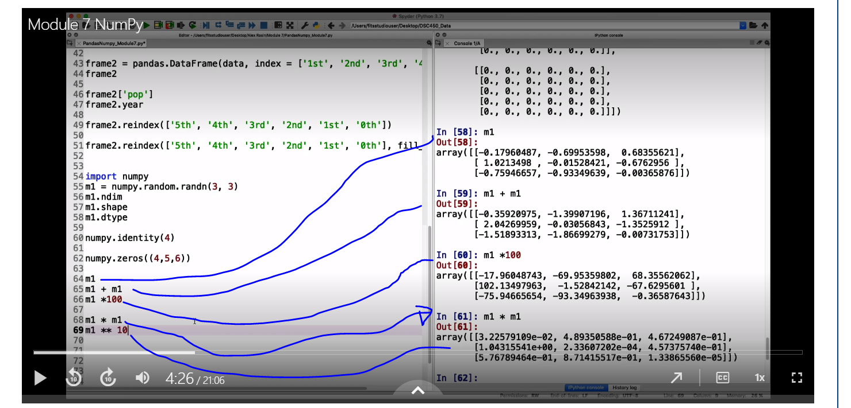

M1 * m1 is not a dot product.

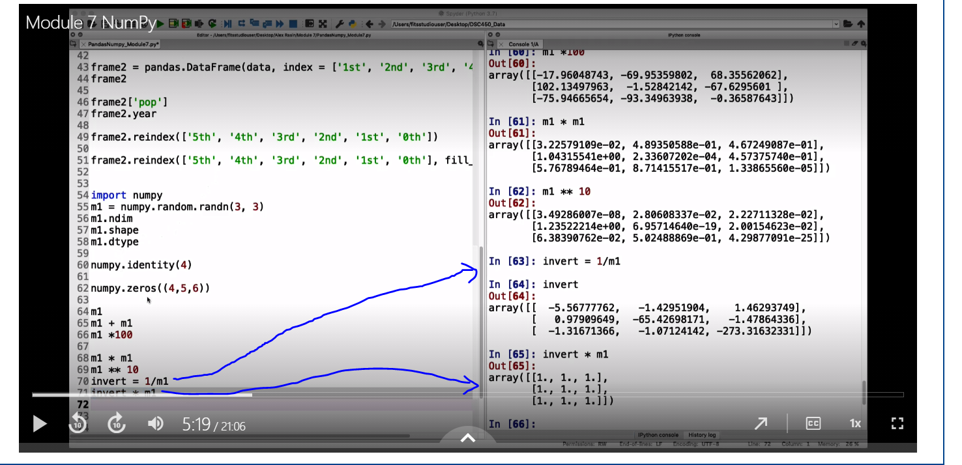

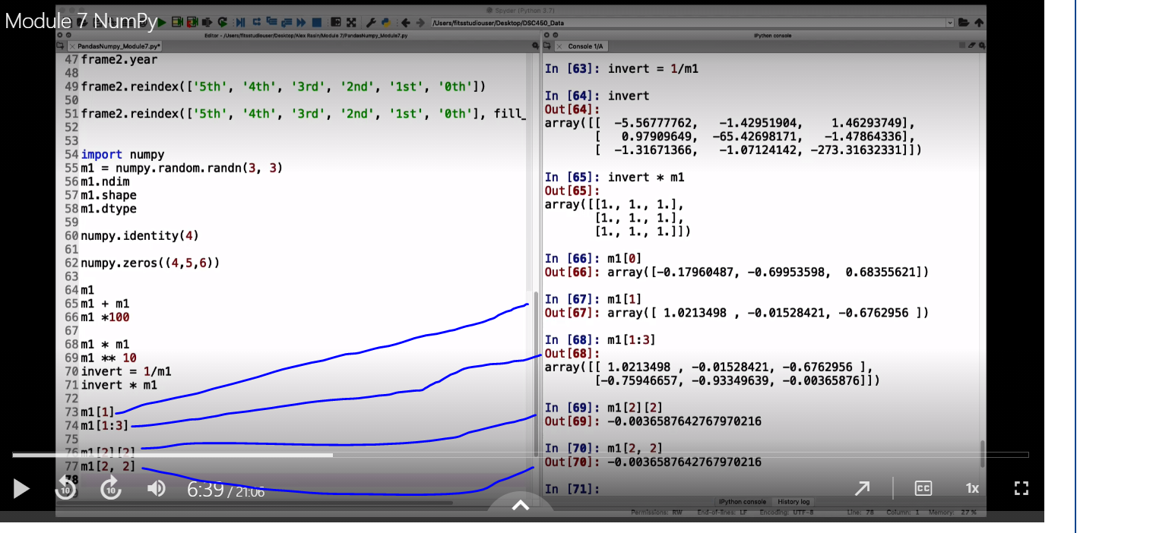

Create an array of names which contains a list of individual strings

Create a a filter which would apply a condition containing boleans.

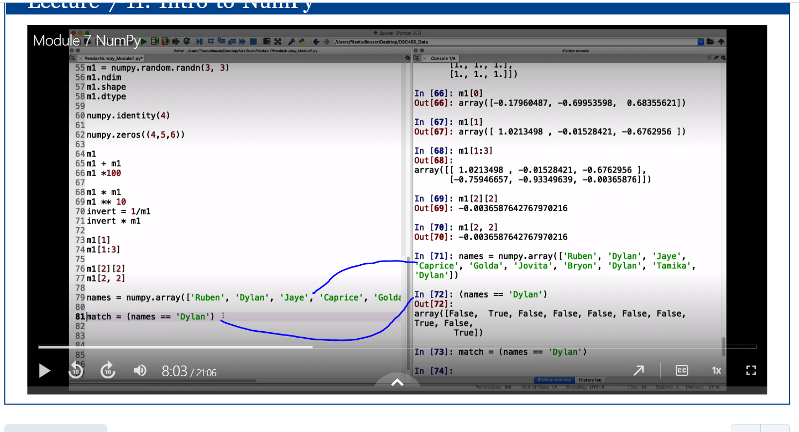

Lets create a new matrix which is a gausian distribution 10 by 5 and this is just random numbers.

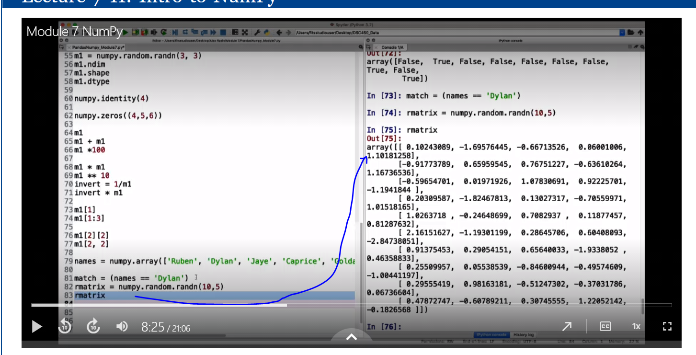

What we are going to do is to apply a set of booleans to filter out some information.

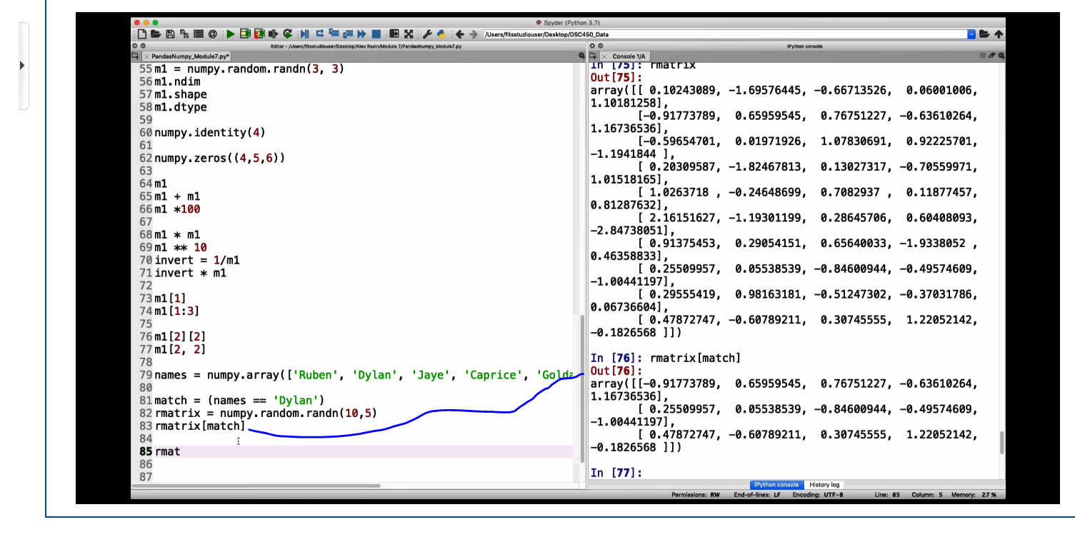

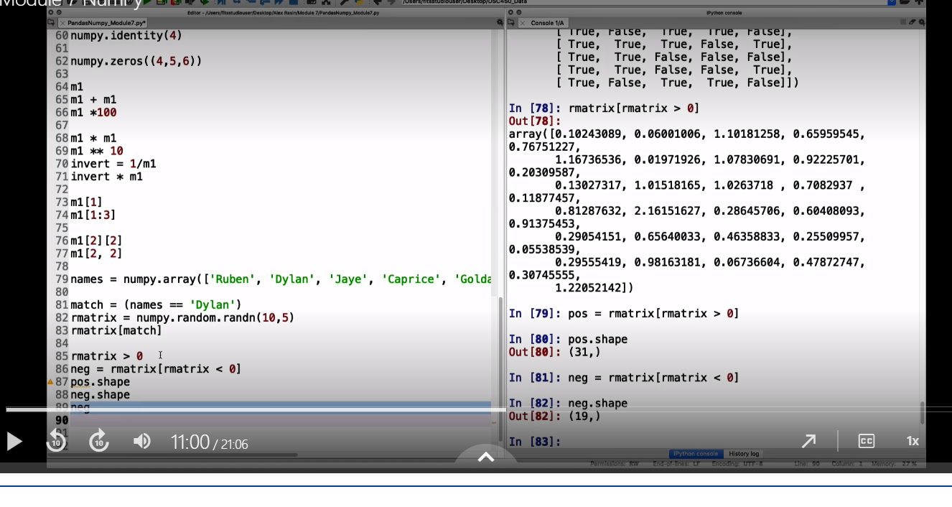

Numpy supports other mathematical operations.

Ceil will round up the numbers

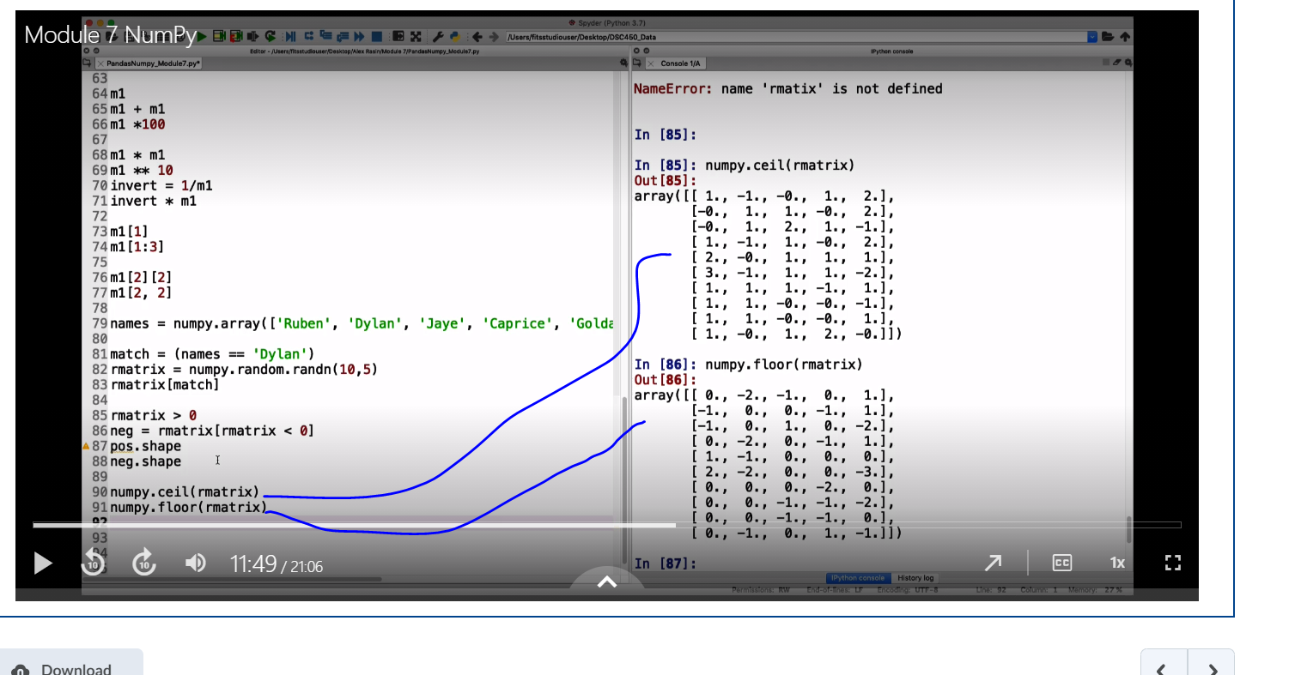

You can compare two different matrices.

You can also use filters:

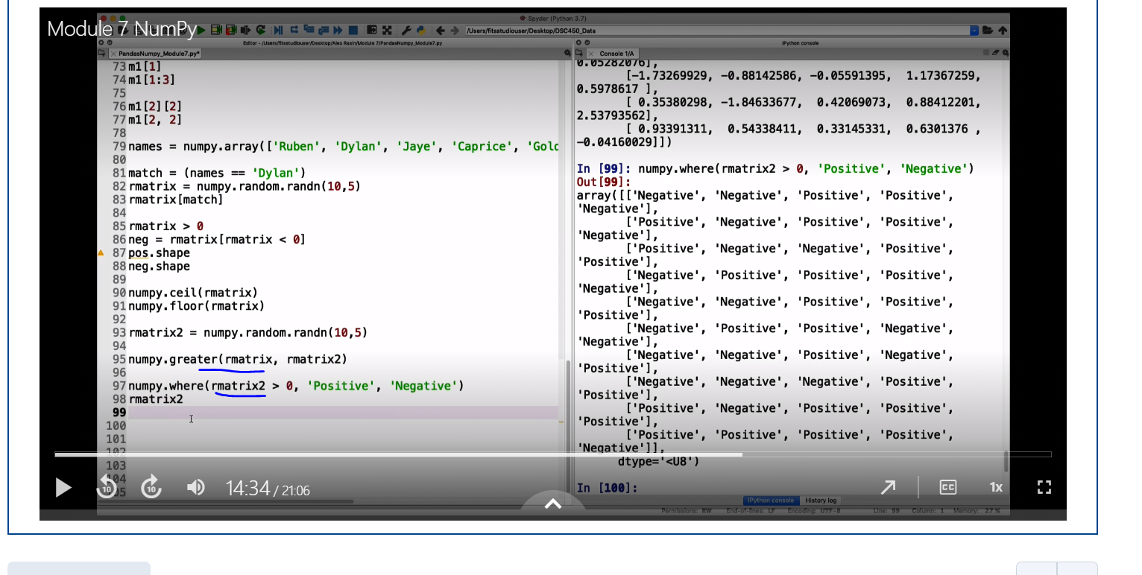

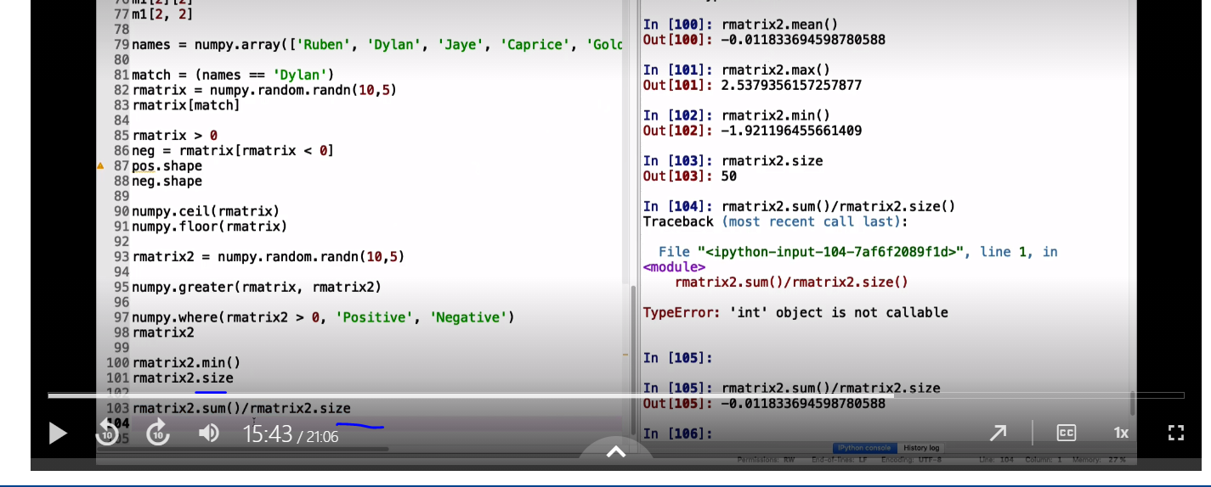

You can sort the matrix,

You can also convert the matrix into a list as below:

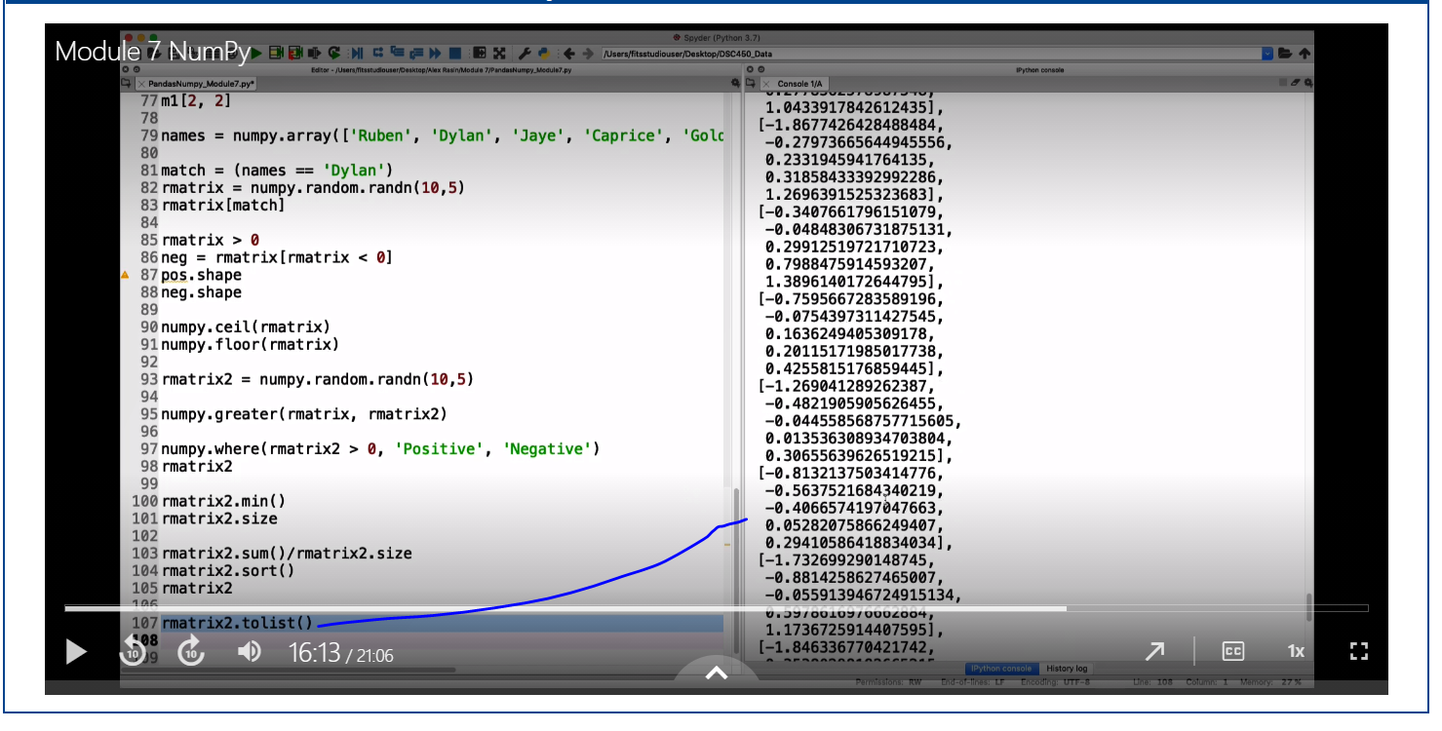

This gives you a standard Python List representation, it is nolonger a numpy constraint.

Numpy supports reading to or loading from a file.

Create a sequence of number using range()

Numpy.arrange(10, 100)

It saves a binary object on the file system.

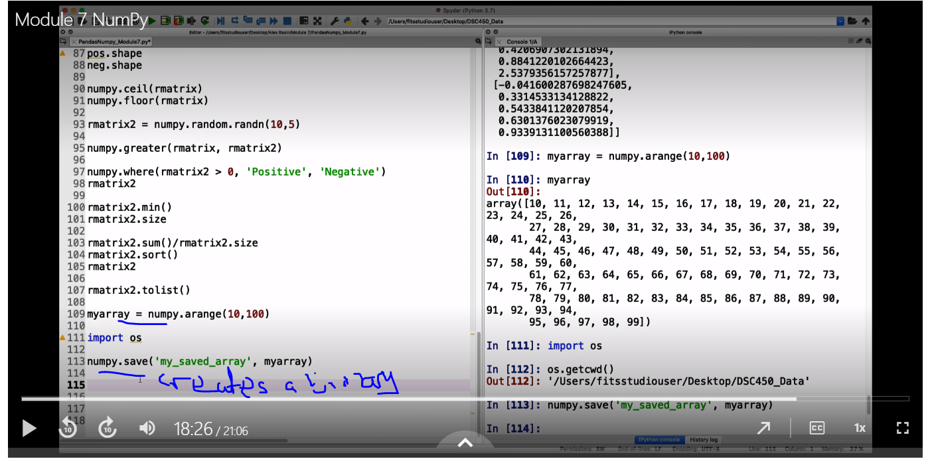

Loading the file:

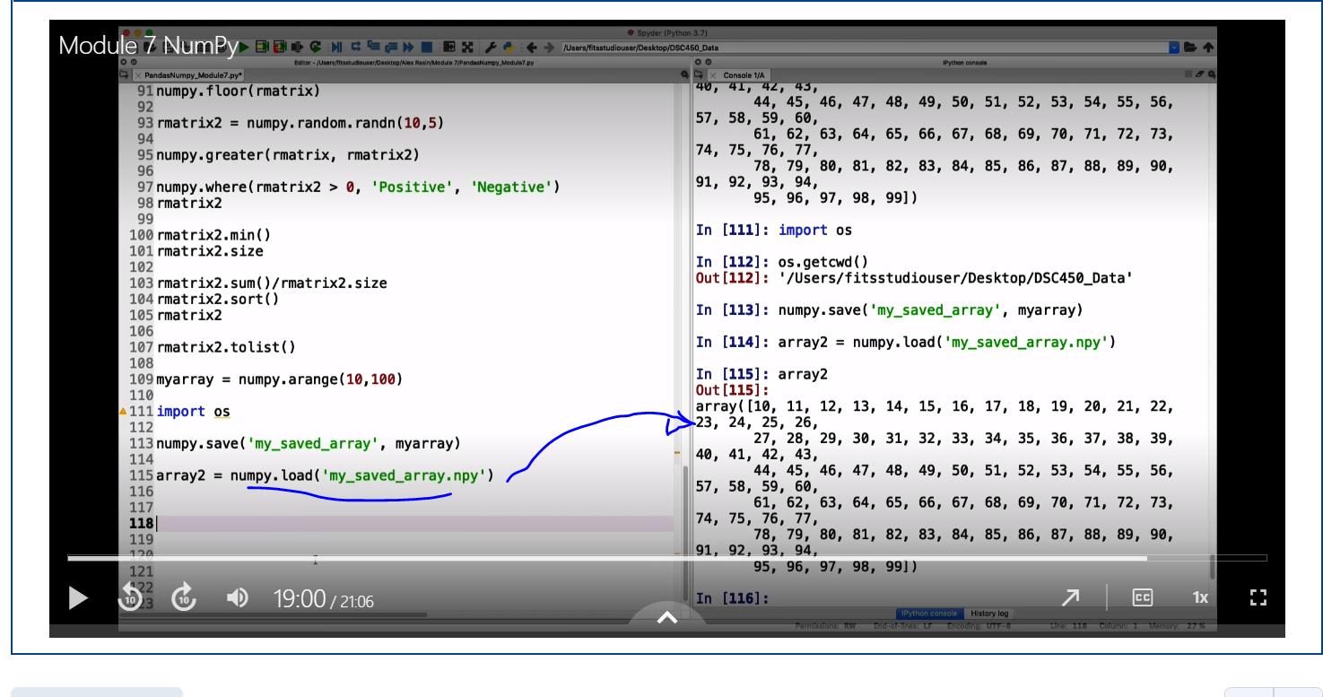

Creating a more user-friendly text format:

Numpy.savetxt(‘my_saved_array2’, myarray)

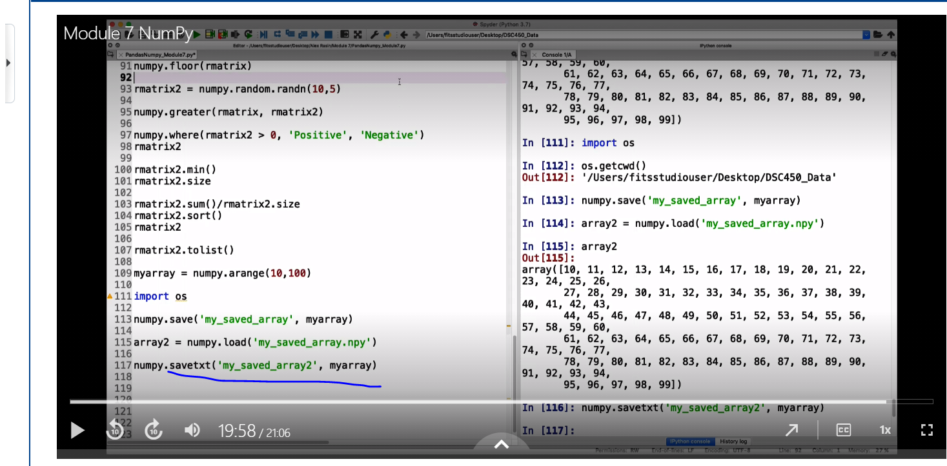

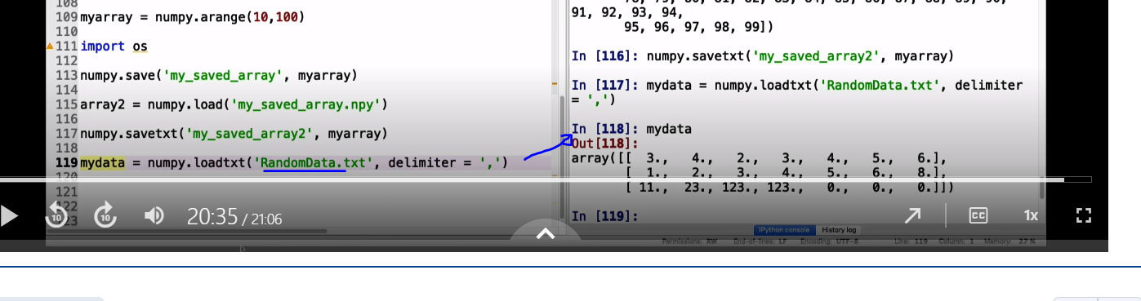

TRIGGERS

